Semester 1, 2026 Narrative

Dear Harper,
It was fantastic to see you share the progress you have made on Pressure this semester. Your exhibition clearly demonstrated how much your project has evolved, and it was great to hear you confidently explain both your creative process and the direction you are taking. Walking us through the earlier versions of your game gave valuable insight into your journey as a game designer. It was interesting to see how your original focus was on experimenting with character and room designs without a clear plan, and comparing that to where your project is now really highlighted the growth you have made. Documenting these earlier iterations was a great decision, as it allows others to appreciate the development of your ideas and reflects the design process behind creating a game.
Your passion for game design and 3D modelling continues to be one of your greatest strengths. Throughout the semester, you have produced an impressive range of high-quality 3D models, including weapons, environments, and characters, while developing your skills across a variety of software. I particularly enjoyed hearing you explain the modelling, texturing, and rendering process, including how you achieved the pixelated style you were aiming for. Your robot model was another standout piece, and your explanation of both the texturing and coding involved showed the depth of knowledge you are continuing to build.
One of the biggest improvements this semester has been the direction of your game. Unlike your earlier version of the game, you now have a much clearer vision for the story, setting, gameplay, and overall experience you want players to have. Your game design document, complete with the background, timeline, and story synopsis, showed how much planning has gone into developing the world you've created. It was also great to hear how you have analysed other games and films, taking inspiration from their storytelling, camera angles, colour grading, sound design, and atmosphere while still creating something that feels uniquely yours.
Not only are your 3D modelling skills impressive, but I can see your passion for storytelling really shining through this project. I loved hearing you explain the eerie atmosphere you are trying to create within the submarine setting and how every design choice contributes to that feeling. It was especially exciting to hear that a friend has already helped create an ambient soundtrack prototype, showing that you recognise how important sound is in creating an immersive experience. It is clear that you have a strong vision for what you want your game to become, and that clarity will continue to guide your development moving forward.
The amount of experimentation you have done with your character and environment designs has also been quite amazing. You shared multiple iterations of your characters, submarines, and weapon designs, explaining how each version helped you refine the final outcome. The level of detail in your textures, anatomy, and mechanical components demonstrates the time, patience, and care you put into every model. Your short animation was another highlight, giving us a glimpse into how your gameplay mechanics are beginning to come together.
One of the things I admire most is how well you have documented your progress. Keeping records of your early concepts alongside your newer designs allows you to reflect on your growth and demonstrates just how much your skills have improved over time. This documentation will become an incredibly valuable resource as your project continues to develop.
Looking ahead, you have already identified some excellent next steps. Developing concept art for your environments and main characters, designing the full game map, and preparing a professional pitch will all help bring Pressure closer to becoming a reality. I also encourage you to begin sharing more of your work online and start connecting with programmers, sound designers, artists, and other creatives who may be interested in joining your project. Building a small team will not only strengthen your game but will also give you valuable experience collaborating within the games industry.
You have built an outstanding foundation this semester, and it is exciting to see how much your vision has developed. I can't wait to see Pressure continue to evolve throughout Semester 2 and beyond and watch your ideas come to life.

Kind regards,
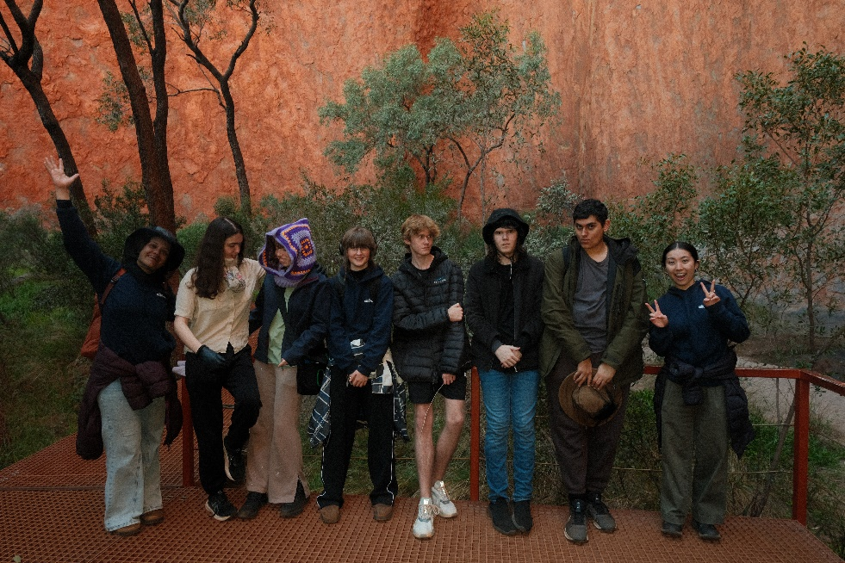
Reyna

