The Plastic Problem: Clearing Our Local Beaches for a Cleaner Coast

Harper Logan Social Action Plan
2026

INTRODUCTION
The issue I have chosen to tackle is the cleanup of excessive marine pollution that is strangling our beautiful native beaches and our sea wildlife. Australia is home to an incredibly diverse and unique ecosystem that can’t be found – or replicated – anywhere else, and must be protected. Our land is literally ‘girt by sea’, and maintaining cleaner oceans is the starting point to a cleaner inland ecosystem. Marine life is still heavily at risk from ocean plastics (for example, a sea turtle has a 22% chance of dying from consuming just a single piece of plastic), and the economic and ecological cost of plastic ingestion is estimated to be over $21 million a year. My goal during my research and action is to see what exactly is polluting our coastal beaches, and if the information online surround coastal pollution matches the findings of the action.

BACKGROUND
Ocean pollution and degradation is an issue that Australia is no stranger to, having first formed the Australian Marine Conservation Society in 1965 to help oppose the mining of the Great Barrier Reef. Originally named as the Queensland Littoral Society it has since been pushing for greater awareness and action against an ever-increasing volume of pollution finding its way through out ocean systems.
The range of groups affected by ocean pollution is wider and more vast than at first glance. While the obvious casualties are the Australian marine life – including sea turtles, whales, dolphins and seals – the effects can, and do, reach humans living inland as well. Australia’s love for all things water related is directly affected by marine pollution as well. Surf culture, seafood eating culture, and beach tourism are all under threat by pollution that either floats in from parts of South Eash Asia or is absorbed or eaten by our marine life, eventually finding its way on to the dinner plates of Australian residents.
Heavy metals and microplastics have already been found in increasing numbers with local seafood, due to prey fish consuming waste which is then eaten by humans. The Australian branch of the WWF have already found that over 145,000 tonnes of plastic are leaking into Australia’s waterways each year. One thing that all concerned groups and experts agree on is that ocean pollution is a problem created by humans, and it will come down to humans to fix it.

SYSTEMS, CAUSES, IMPACTS
The problem with Australia’s ocean pollution branches from two main sources: internal land-based litter, and external debris arriving to our shores via long distances.
The waste coming from within Australia is derived from several sources, including an extreme over-abundance of single-use plastics, cigarette butts and discarded packaging. In addition to these there is also an alarming amount of runoff and discharge from treatment plants and waste particles that end up being washed out into local waterways. Clean Up Australia have released figures that estimate that over 130,000 tonnes of plastic leak into Australia’s broader and coastal environment every year.
The Australian Marine Conservation Society has pointed out very clearly how best to tackle this issue, with the chief concern being to stop household waste at its source. Cutting all single-use materials to reusable ones is the first step in this process. Once the flow of outgoing waste is stemmed the next priority is to clean up our existing debris, an exercise that not all experts, community members, and government officials have all been able to agree on. While the Australian Government has put many EPR’s in place (Extended Producer Responsibility) many locals feel that big companies aren’t adhering to these as they are more voluntary in nature, with fines being paid but excessive waste still being produced. At the end of all this it’s not just our marine life that suffers, but the general population as well, with more and more locals having their health put at risk.

DATA

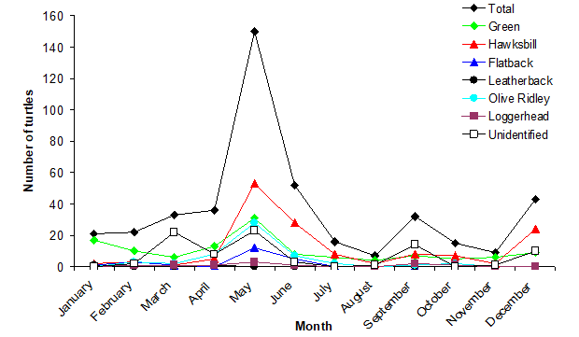
Figure 1 - Number of sea turtles affected left stranded due to pollution
The data shown above is a graph provided by the Australian Department of Climate Change, Energy, the Environment and Water, and shows the Dynamics and Distribution of Affected Marine Turtles. It follows the below list which identifies the various types of plastic waste that affects marine life:
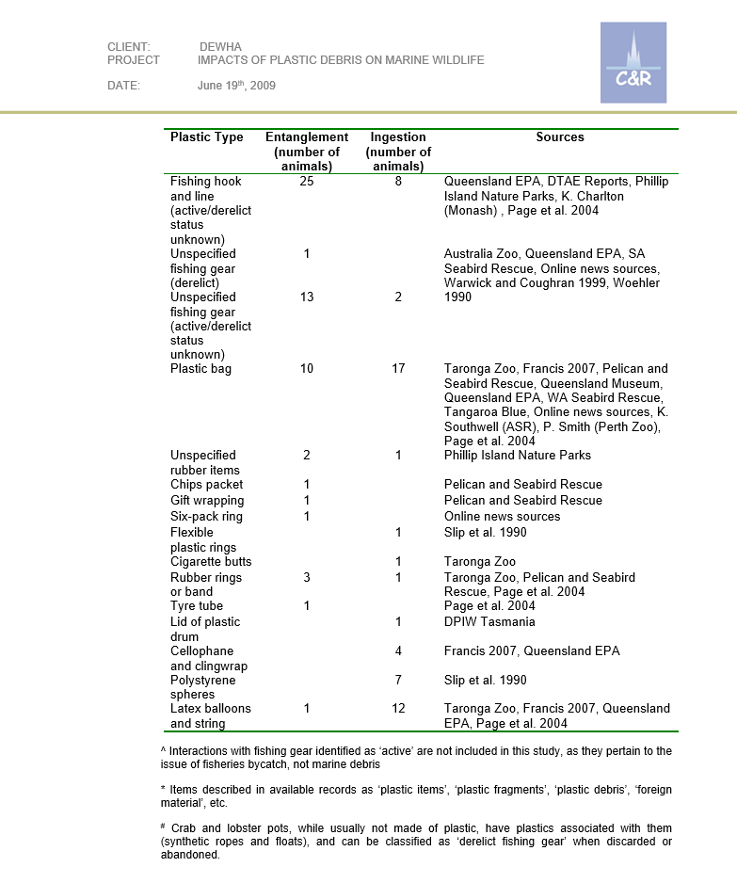
Figure 2
This data coincides with the previously mentioned statistic regarding sea turtles and their survivability percentages after consuming plastics.
All of this data converges with a common thread, which is that all of our marine life is being affected by pollution sourced from within Australia i.e. polystyrene and local packaging, cigarette butts, and that solutions to our ocean pollution problems must come from within.
ACTION
The action that I took was to undertake an organised beach clean-up event. I spoke to my fellow classmates at our regular Town Halls to spread the word, and also sent emails to see who would be interested in participating. In total five students including myself arrived at Broadbeach Parade and took part in a beach clean-up.
I signed up for a clean-up event via the Clean Up Australia website, and used equipment provided by the school. We ended up collecting a large amount of trash, more than we were expecting, and it raised the attention of the many early beach-goers who were interested to see our efforts. In the hour that we operated we managed to collect approximately 450 pieces of garbage from the beach area.
The types and amount of rubbish collected & recycled were as follows:
- 16 recyclable items
- 334 pieces of general waste
- 30 pieces of plastic scrap
- 88 cigarette butts
- E-waste (an electronic speaker)
- 1 lighter
- 1 entire book
It became clear by the end of the day the group of the five of us would not nearly be enough to clean the immediate beach area, and that it was a job daily attention from more hands. We managed to make a noticeable dent in the area directly around the surf club, but there was rubbish we observed even into the dense shrubs along the beach.
A sustainable solution for cleaning up the vast amount of waste on our Australian beaches requires far more dedication, time and resources than what were available to us on the day.

CONCLUSION & REFLECTION
Overall the event was a success. It wasn’t as big as a success as I would have hoped, but only due to the limited amount of time and manpower available to us. Out of my entire year level only one student attended after hearing about the event via the Town Hall, all the other attendees were friends that I personally asked.
Some of the challenges we faced were that some members of the public were visibly uncomfortable with our presence on the beach. We acted politely and respected people’s space and their time on the beach, but considering we were there to help clean the space we were met with apprehension. We also had to steer clear of potentially dangerous characters, who may or not have been conducting ‘business’ in the nearby shrubbery.
The event was successful though, as everyone was enthusiastic and thorough, and because of this we ended up collecting roughly 450 pieces of rubbish, which is not bad for only an hour’s worth of work.

PERSONAL RELFECTION
Organising the event gave me a very unique perspective on what it was like to organise groups of people for social functions. It was a great day to be outside, but it required a lot more work than I originally anticipated.
The only thing I would do differently would be to advocate more for students to get involved. I previously attempted to schedule the cleanup for the term prior but was held back due to illness, which I think may have demotivated people from participating so late in the year.

FUTURE HOPES
I feel moved and also saddened by the state of our local beaches after this event, but I also feel like it’s a job much bigger than me and what I am capable of at this point in time. Having said that, I love going to the beach, it’s something I have done since I was a little boy, and I feel like I will be much more mindful in my future visits to ensure no one leaves any of their waste behind.

BIBLIOGRAPHY

Tan, T. (2024, February 21). Pollution. State of the Environment 2023. https://soe.epa.sa.gov.au/environmental-themes/sea/protecting-our-sea/sea-pollution
Reisser, D. J. (2020, July 22). International connection to Australian ocean plastic crisis uncovered. Www.Uwa.Edu.Au. https://www.uwa.edu.au/news/article/2020/july/international-connection-to-australian-ocean-plastic-crisis-uncovered
Jun 27, 2025, 12:00:00 AM. (2025, June 27). Plastic in our oceans is killing marine mammals. Latest Blogs. Wwf.Org.Au. https://wwf.org.au/blogs/plastic-in-our-oceans-is-killing-marine-mammals
Hossain, R., Ghose, A., & Sahajwalla, V. (2024). Microplastics pollution in Australia: Sources, impacts, and mitigation strategies. Case Studies in Chemical and Environmental Engineering, 11, 101036. https://doi.org/10.1016/j.cscee.2024.101036
Department of Climate Change, Energy, the Environment and Water. (2022). Marine pollution - DCCEEW. Dcceew.Gov.Au. https://www.dcceew.gov.au/environment/marine/marine-pollution
corporateName=Commonwealth Parliament; address=Parliament House, C. (2024). Chapter 4 - the environmental impacts of plastic pollution in oceans and waterways. Www.Aph.Gov.Au. https://www.aph.gov.au/Parliamentary_Business/Committees/House/Climate_Change_Energy_Environment_and_Water/Plasticpollution/Report/Chapter_4_-_The_environmental_impacts_of_plastic_pollution_in_oceans_and_waterways
Australian Marine Conservation Society. (2018). Ocean plastic pollution. Australian Marine Conservation Society. https://www.marineconservation.org.au/ocean-plastic-pollution/
Australian Government. (2024, June 26). Impacts of plastic debris on Australian marine wildlife - DCCEEW. Dcceew.Gov.Au. https://www.dcceew.gov.au/environment/marine/marine-pollution/marine-debris/impacts-plastic-debris-australian-marine-wildlife

